Scent Dispenser – Firmware Flash Instructions
Initial Setup
- Ensure Python 3 is installed (download from https://www.python.org/downloads/)
- Navigate to the utility directory containing the flash.py script
- Execute the setup.bat (or setup.sh on MacOS) to install the required modules
Flashing Procedure
- Connect the UPDI programmer to the 3-pin header on the device. If using the “UPDI Friend” device, connect the wires as follows:
  - RED: +3V3
  - WHITE: RESET
  - BLACK: GND
- Ensure the switch on the programmer is placed in the 3V position.
- Double-check that the wiring is correct, and then connect the programmer to an available USB port.
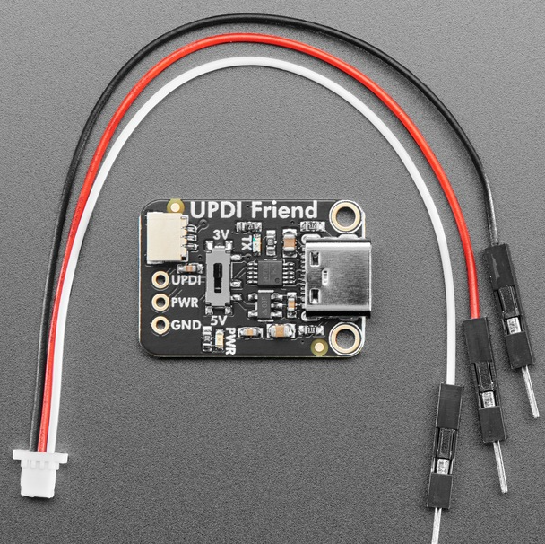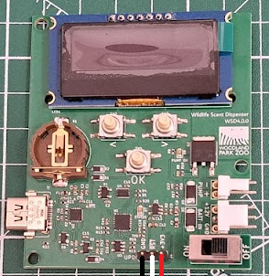
- Navigate to the utility directory and open a new terminal window. (On Windows, hold shift, and right-click, and select “Open Powershell/Command window here”)
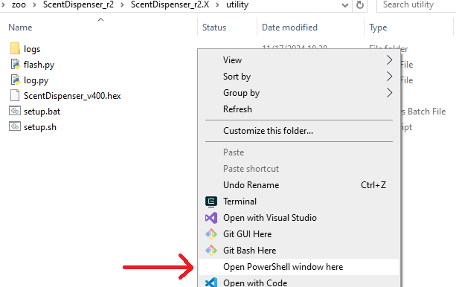
- Run the command as shown below, replacing the filename with the desired firmware to flash. If you know the COM port associated with the programmer, add the option “-p [COM port]”. Otherwise, the script will prompt for a port to be chosen.
.\flash.py flash =f .\ScentDispenser_v421.hex
- If a port was not specified in step 5, select the port associated with the programmer from the list of options presented, and press Enter.
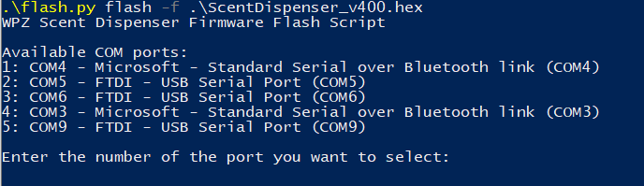
- The firmware flash process will take approximately 1 minute. At the completion, the device will restart.
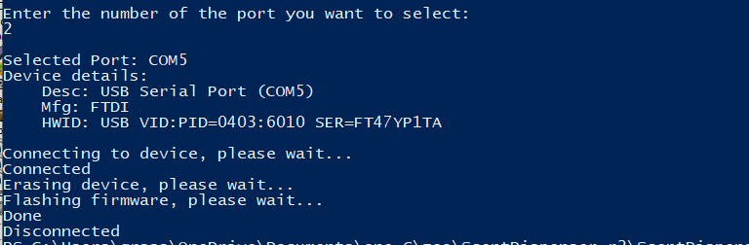
Procedure to Set Device ID
- Repeat steps 1-4 from the above section “Flashing Procedure”
- Run the command as shown below, specifying the desired device ID.
.\flash.py set-id -n “DEVICE 123” -p COM5
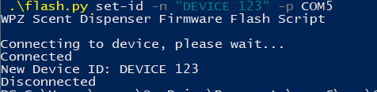
- The device ID is limited to 16 characters.
- If a COM port is not specified, the script will prompt to select the port associated with the programmer
- The device will restart upon completion

Procedure to Download Log Data
- Connect to the dispenser device via the on-board USB type C connector.
- Navigate to the utility directory and open a new terminal window. (On Windows, hold shift, and right-click, and select “Open Powershell/Command window here”)
- Run the command shown below. Log data will be downloaded into the directory “./logs/[DEVICE ID].csv”. If the file exists, it will be appended with the new data. The script should automatically detect the correct COM port when “-p auto” is specified. Otherwise, specify the port manually.
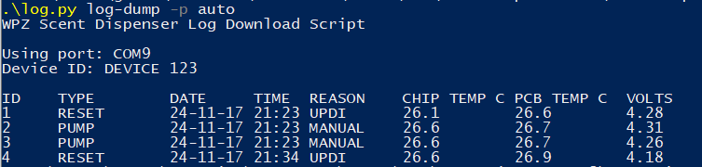
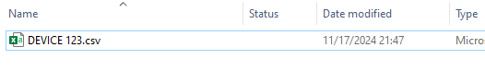
- Once the log data is retrieved, the device memory can be cleared with the below command.
.\log.py log-clear -p auto
